Q. No. | Question and options | Answer
Q1 | Which of the following igneous rock formed due to solidification of magma at a relatively shallow depth and possess a finely grained crystalline structure | Dolerite
A | Syenite
B | Dolerite
C | Basalt
D | Marble
Q2 | Methods of test for determination of tensile strength of natural building stones is addressed in | IS:1121 (Part 3)-2012
A | IS:800-2007
B | IS:1121 (Part 3)-2012
C | IS:2386 (Part I)-1963 (Reaffirmed 2002)
D | IS:383 (Part I)-1963 (Reaffirmed 2002)
Q3 | According to IS 1077, water absorption of common burnt clay building bricks shall not be more than -----------percent by weight up to class 12.5 | 20
A | 10
B | 15
C | 20
D | 25
Q4 | Specific surface of Sulphate resistant Portland cement shall not be less than | 225 m²/kg
A | 175 m²/kg
B | 225 m²/kg
C | 300 m²/kg
D | 350 m²/kg
Q5 | According to IS 2250-1981(Reaffirmed 2000) consistency of mortar for filling cavities shall be in the range of | 130 mm to 150 mm
A | 40 mm to 50 mm
B | 70 mm to 100 mm
C | 130 mm to 150 mm
D | 180 mm to 210 mm
Q6 | Which of the following is the Correct statement with respect to Gypsum | Gypsum sets by natural process of crystallization
A | Gypsum cannot be used as an insulating material to protect wood or metal columns
B | Gypsum is affected by bacteria so necessary protective measures should be taken when used
C | Gypsum is soluble in water
D | Gypsum sets by natural process of crystallization
Q7 | The transparent glass can be made opaque by | Grinding the surface of glass by emery
A | Allowing the fabricated glass to cool in a controlled manner
B | Grinding the surface of glass by emery
C | Using diamond cutter
D | Heating the glass in an oven to a suitable temperature
Q8 | Which of the following material is used as an inert tiller or extender in making paint | Talc
A | Linseed oil
B | Aluminium powder
C | Talc
D | Burnt umber
Q9 | A soil sample has a porosity of 30 %. The specific gravity of soil is 2.65. Calculate the dry density of soil | 18.2 kN/m³
A | 14.5 kN/m³
B | 18.2 kN/m³
C | 21.3 kN/m³
D | 26.5 kN/m³
Q10 | Consider the below mentioned statements  - For a given soil sample increasing compactive energy results in an increase in the maximum dry density.  - For a given soil sample increasing compactive energy result in decrease in the optimum water content.  Identify the correct statement | Both statements are true
A | Statement A is true B is false
B | Statement B is true A is false
C | Both statements are true
D | Both statements are false
Q11 | Weight of hammer used in standard penetration test for the assessment of strength and other properties of soil is | 63.5 kg
A | 35.5 kg
B | 41.5 kg
C | 55.2 kg
D | 63.5 kg
Q12 | Which of the following statement is incorrect with respect to direct shear test. | Normal stresses and Shearing stresses over the potential surface of sliding is uniform
A | Normal stresses and Shearing stresses over the potential surface of sliding is uniform
B | As test progress, the area under shear gradually decreases
C | As compared to the Triaxial test, there is little control on the drainage of soil
D | The plane of shear failure is predetermined, which may not be the weakest one.
Q13 | According to IS:6403-1981; what is the value of shape factor for continuous strip | 1.0
A | 0.8
B | 1.3
C | 1.0
D | 1.2
Q14 | In hydrometer method of sedimentation analysis, The hydrometer reading corrected for meniscus is given by---------- where, R_{h}¹=Observed hydrometer reading at the top of meniscus.  C_{m}=meniscus correction. | R_{h}=R_{h}¹+C_{m}
A | R_{h}=R_{h}¹+C_{m}
B | R_{h}=R_{h}¹-C_{m}
C | R_{h}=R_{h}¹/C_{m}
D | R_{h}= R_{h}¹*C_{m}
Q15 | Which of the following method used for removal of excess water from the saturated soil is suitable for fine grained cohesive soil. | Electro-Osmosis method
A | Ditches and sumps
B | Shallow well method
C | Vacuum method
D | Electro-Osmosis method
Q16 | Identify the type of soil structure given below  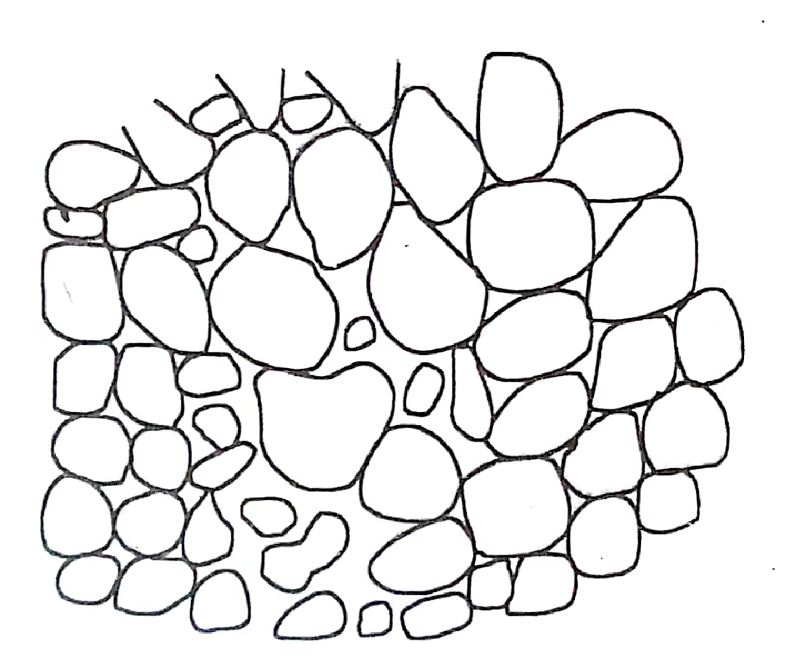 | Single grained
A | Single grained
B | flocculent
C | Dispersed
D | Honeycomb
Q17 | If the one side surface area of partly paneled and partly glazed door is 2.6 m² ,Total painting work quantity is =-------m² | 5.2
A | 2.6
B | 6.5
C | 3.9
D | 5.2
Q18 | The expected out-turn of a stone cutter for an item of work “Ashlar stone dressing” is | 0.70 cu m per day
A | 0.25 cu m per day
B | 0.70 cu m per day
C | 1.20 cu m per day
D | 1.60 cu m per day
Q19 | Calculated the quantity of earthwork by mid sectional area method for 200 meter length embankment for a portion of road in an uniform ground the heights of banks at the two ends being 1.2 m and 1.8m. The formation width is 10 meter and side slopes 1.5H:1V and no transvers slope. | 7500.00 cu m
A | 6532.00 cu m
B | 7500.00 cu m
C | 7456.00 cu m
D | 8123.00 cu m
Q20 | For the construction of RCC beam 4 numbers of 6 m length, 16 mm diameter HYSD bars are required. Estimated weight of steel excluding wastage is | 38.88 kg
A | 9.47 kg
B | 38.88 kg
C | 45.42 kg
D | 51.35 kg
Q21 | Consider the below statements and identify correct statement/s.  - In a detailed estimate the Abstract of estimate does not provides the total estimated cost of the project.  - In a detailed estimate the Abstract of estimate provides the various items of work to be carried out to complete the project. | Statement B is true A is false
A | Statement A is true B is false
B | Statement B is true A is false
C | Both statements are true
D | Both statements are false
Q22 | Calculate the volume of sand required for making 3 cu m of concrete with nominal mix 1:2:4 for construction of RCC beams is | 1.32 cu m
A | 1.21 cu m
B | 1.32 cu m
C | 1.53 cu m
D | 2.00 cu m
Q23 | A power generator is installed in an apartment at a cost of Rs 25000. Assuming the life of the generator as 15years, calculate the annual installment of sinking fund. interest =4% compounded annually | Rs 1250
A | Rs 1250
B | Rs 2300
C | Rs 1500
D | Rs 1450
Q24 | A property fetches a net annual income pf Rs.9000 deducting all outgoings. Workout the capitalized value of property if the rate of interest is 5% per annum | Rs. 1,80,000
A | Rs. 1,30,000
B | Rs. 1,50,000
C | Rs. 1,80,000
D | Rs. 2,10,000
Q25 | Length of a simple circular curve of radius 500m is 350 m calculate the deflection angle of curve | 40⁰ 6’
A | 30⁰ 25’
B | 35⁰ 10’
C | 40⁰ 6’
D | 48⁰ 7’
Q26 | Pick odd one out with respect to method of setting out of simple circular curves | Setting out simple circular curve by Rankine’s method of tangential angles.
A | Setting out simple circular curve by ordinates from long chord method
B | Setting out simple circular curve by offsets from the tangents method
C | Setting out simple circular curve by Rankine’s method of tangential angles.
D | Setting out simple circular curve by successive bisection of arcs method
Q27 | A steel tape 30 m long standardized with a pull of 12kg was used for measuring a baseline. Find the correction for sag if the pull exerted at the time of measurement was 19 kg. Take weight of steel tape as 1.2 kg. | 4.98 mm (subtractive)
A | 0.498 mm (subtractive)
B | 4.98 mm (subtractive)
C | 49.8 mm (subtractive)
D | 498 mm (subtractive)
Q28 | In a levelling work, Back sight reading at a point P is 3.120 m and fore sight at Q is 4.315 m from an instrument station, if the R L of point P is 120 m calculate the R L of point Q. | 118.805 m
A | 118.805 m
B | 121.195 m
C | 123.120 m
D | 124.315 m
Q29 | According to which method of balancing the traverse “the total error in latitudes and in departure is distributed in proportion to the latitudes and departure of the sides”? | Transit method
A | Bowditch’s method
B | Transit method
C | Graphical method
D | The axis method
Q30 | The type of levelling which make use of the phenomenon that difference in elevation between two points is proportional to the difference in atmospheric pressures at these points is called | Barometric levelling
A | Spirit levelling
B | Barometric levelling
C | Trigonometric levelling
D | Differential levelling
Q31 | Length of base line in case of third order or tertiary triangulation shall be in the range of | 0.5 km to 3 km
A | 0.5 km to 3 km
B | 1.5 km to 5 km
C | 5 km to 15 km
D | 15 km to 25 km
Q32 | In photogrammetric surveying an aerial photograph taken with the camera axis directed intentionally between the horizontal and the vertical plane is called | Oblique photograph
A | Vertical photograph
B | horizontal photograph
C | Tilted photograph
D | Oblique photograph
Q33 | Calculate the maturity of concrete at the age of 14 days when cured at an average temperature during day time 21⁰ C, and night time 9⁰ C. take datum temperature as  -11⁰ C | 8736⁰Ch
A | 5040⁰Ch
B | 6351⁰Ch
C | 8736⁰Ch
D | 9124⁰Ch
Q34 | Load at failure of a concrete sample tested for split tensile strength as per IS 5816-1999 is 125 kN, calculate split tensile strength of concrete. Take diameter cylindrical of specimen = 150 mm, Length of cylindrical specimen = 300 mm. | 1.768 N/mm²
A | 1.523 N/mm²
B | 1.768 N/mm²
C | 1.951 N/mm²
D | 2.164 N/mm²
Q35 | The aspect ratio of fibres beyond which the strength and toughness of fibre reinforced concrete reduced is | 75
A | 25
B | 50
C | 75
D | 100
Q36 | Identify the incorrect statement with respect to reinforcement requirement in columns | Spacing of longitudinal bars measured along  the periphery of the column shall not exceed  75 mm.
A | The cross-sectional area of longitudinal reinforcement, shall be not less than 0.8 percent of the gross cross sectional area of the column.
B | The minimum number of longitudinal bars  Provided in a column shall be four in rectangular columns and six in circular columns.
C | The bars shall not be less than 12 mm in diameter.
D | Spacing of longitudinal bars measured along  the periphery of the column shall not exceed  75 mm.
Q37 | According to IS 456-2000, maximum width of cracks in RCC members where cracking in the tensile zone is exposed to continuous moisture or in contact soil or ground water is | 0.20 mm
A | 0.05 mm
B | 0.20 mm
C | 0.45 mm
D | 0.65 mm
Q38 | According to IS 456-2000, the maximum area of compression reinforcement in beams shall not exceed________ | 0.04bD
A | 0.02bD
B | 0.04bD
C | 0.06bD
D | 0.08bD
Q39 | According to I.S. specifications, rivets or bolts carrying a calculated shear stress through a packing more than 6 mm thick should be increased by how much percentage for each 2 mm thickness of packing | 2.5 %
A | 1.5 %
B | 2.5 %
C | 3.5 %
D | 5 %
Q40 | The shortest distance from the root of the fillet weld to the face of the weld is termed as | Effective Throat thickness
A | Effective displacement
B | Effective Throat thickness
C | Effective plate thickness
D | Effective depth
Q41 | The presence of barium present in water causes | Toxic effects on the heart and blood vessels
A | Discolouration of cloths
B | Dental fluorosis
C | Toxic effects on the heart and blood vessels
D | Infant methemoglobinemia
Q42 | Pick odd one out with respect to type of impurities present in water | Silts
A | Silts
B | Calcium
C | Sodium
D | Selenium
Q43 | Compute the fire demand for a city having population of 250000 using kuichling’s formula | 71,151.68 litres/minute
A | 71,151.68 litres/minute
B | 38,971.38 litres/minute
C | 1,26,628 litres/minute
D | 2,50,000 litres/minute
Q44 | Which of the following method of forecast assumes that “the percentage increase in population from decade to decade is constant”? | Geometrical increase method
A | Arithmetical increase method
B | Geometrical increase method
C | Logistic method
D | Graphical extension method
Q45 | For a mixed media filter, determine the particle size of anthracite which have settling velocity equal to that of silica sand of 0.4 mm in diameter. Take specific gravity of sand and anthracite as 2.65 and 1.45 respectively. | 0.95 mm
A | 0.6 mm
B | 0.8 mm
C | 0.95 mm
D | 1.05 mm
Q46 | Sewer pipes of sizes greater than 0.4 m diameter are designed as running -----full at maximum discharge. | 75%
A | 25%
B | 50%
C | 75%
D | 100%
Q47 | Non-biodegradable organics in water are usually Measured by determining - | Chemical oxygen demand
A | biological oxygen demand
B | Chemical oxygen demand
C | Aerobic oxygen demand
D | Total oxygen demand
Q48 | Fire demand for a city having population of 1,40,000 according to Kuichling’s formula is | 37650 liter/min
A | 37650 liter/min
B | 45189 liter/min
C | 55681 liter/min
D | 29234 liter/min
Q49 | Maximum value of cross slope that can be provided for earth shoulder is | 5%
A | 3%
B | 5%
C | 7%
D | 9%
Q50 | The most important recommendation made by the Jaykar committee in the year 1928 is | Central road fund
A | Central road fund
B | Motor vehicle act
C | National highway act
D | National transport policy
Q51 | The PCU recommended by the IRC for Agricultural tractor on rural roads is | 1.5
A | 0.5
B | 1.0
C | 1.5
D | 3.0
Q52 | Calculate the radius of loaded area in flexible pavement by taking design wheel load as 3500 kg and tyre pressure of 4 kg/cm² | 16.68 cm
A | 16.68 cm
B | 21.65 cm
C | 29.58 cm
D | 33.28 cm
Q53 | Kinks in rails are formed due to | Movement of ends of adjoining rails slightly out of position
A | Movement of ends of adjoining rails slightly out of position
B | Battering action of wheels over the end of rails
C | Prevention of expansion of rails in hot weather on account of temperature
D | Action of heavy axle loads on rails
Q54 | The first proposal for the construction of railways in India was submitted to east India company by -------- | Mr. R.M. Stephenson
A | Lord Ramsay
B | Mr. R.M. Stephenson
C | Arthur cotton
D | Lord Falkland
Q55 | The maximum value of super elevation, according to the railway board is ------ | 1/10th of gauge
A | 1/10th of gauge
B | 1/25th of gauge
C | 1/50th of gauge
D | 1/100th of gauge
Q56 | Find out the number of sleepers required for constructing a broad gauge railway track of length 640m. Take sleeper density as M+5 | 890
A | 790
B | 890
C | 990
D | 1150
Q57 | The whole area enclosed between an imaginary boundary line which can be included in an irrigation project for supplying water to agricultural is known as | Gross Command Area
A | Culturable Command area
B | Gross Command Area
C | Unculturable area
D | Culturable cultivated area
Q58 | Determine the ‘crop ratio’ of kharif to rabi crop if the area under kharif crop is 2500 hectares and the area under rabi crop is 5000 hectares. | 1:2
A | 1:4
B | 1:1
C | 2:1
D | 1:2
Q59 | In an irrigation canal the velocity of water at -------- represents the mean velocity | 0.6 times the depth of water
A | Surface of water
B | 0.6 times the depth of water
C | Half the depth of water
D | Bed level
Q60 | The maximum discharge through an irrigation trapezoidal channel having bed width 4m, side slope 1:1 and full supply depth 1.5m. the water flows with a velocity 1m/s is | 8.25 cumecs
A | 6.225 cumecs
B | 62.25 cumecs
C | 0.825 cumecs
D | 8.25 cumecs
Q61 | The depth of water to be maintained for a crop having base period of 100days and the duty is 1000hectares per cumecs is ----------- | 8.64cm
A | 0.864m
B | 8.64cm
C | 86.4cm
D | 864 m
Q62 | The maximum discharge through an irrigation channel flowing with velocity of 1 m/s, having bed width 4m, side slope 1:1 and ratio of bed width to wetted depth as 4 is | 5 cumecs
A | 4 cumecs
B | 6 cumecs
C | 5 cumecs
D | 7 cumecs
Q63 | The head loss across a hydraulic jump in a rectangular channel with pre jump and post jump height as 2m and 5m is ---------- | 0.675m
A | 0.225 m
B | 0.675 m
C | 2.025 m
D | 0.075 m
Q64 | The force exerted by a jet of water on a stationary vertical plate in the direction of jet is given by__  (p = mass density of liquid, a= area of jet, V=velocity of the jet before striking the plate  , u= velocity of the flat plate held normal to the jet) | Pa(V-u)²
A | paV²
B | paV³
C | Pa(V-u)²
D | Pa(V-u)³
Q65 | Absolute pressure in a fluid is equal to | Atmospheric pressure plus gauge pressure
A | Atmospheric pressure + gauge pressure
B | Gauge pressure- Atmospheric pressure
C | Atmospheric pressure + vacuum pressure
D | Vacuum pressure + gauge pressure
Q66 | The point of application of force of buoyancy on the body is known as | Centre of buoyancy
A | Centre of gravity
B | Centre of buoyancy
C | Metacenter
D | Centre of balance
Q67 | For the most economical Trapezoidal channel section , one of the sloping sides shall be equal to | Half of top width
A | Base width
B | Top width
C | Half of base width
D | Half of top width
Q68 | Critical depth of 8m wide channel conveying 15 m³/s of water at a depth of 1.2 m is | 0.71m
A | 0.71m
B | 0.81m
C | 1.42 m
D | 1.62 m
Q69 | In a open channel, alternate depths of flow are the depths | which occur at the same specific energy
A | which occur at the same specific energy
B | At which total energies are same
C | For the same specific force
D | At which pressure heads are same
Q70 | Open channel flow is sub critical when fraud’s number is | Less than unity
A | Less than unity
B | Equal to unity
C | More than unity
D | Zero

